


Mastering Embedded System Online Diploma
www.learn-in-depth.com

SafePressure Alert

Use Case Document
First Term (Final Project 1)

Eng. Abdallah Shabaan Ghazy
email:abdallah.shabaan.ghazy@gmail.com

My Profile:
https://www.learn-in-depth-store.com/certificate/abdallah.shabaan.ghazy%40gmail.com

Use Cases for Pressure Control System (PCS)

Version 1.0 approved
Prepared by: Abdallah Shabaan Ghazy
Organization: learn in depth
Date Created: 8/11/2024

Revision History

Use Case Diagram
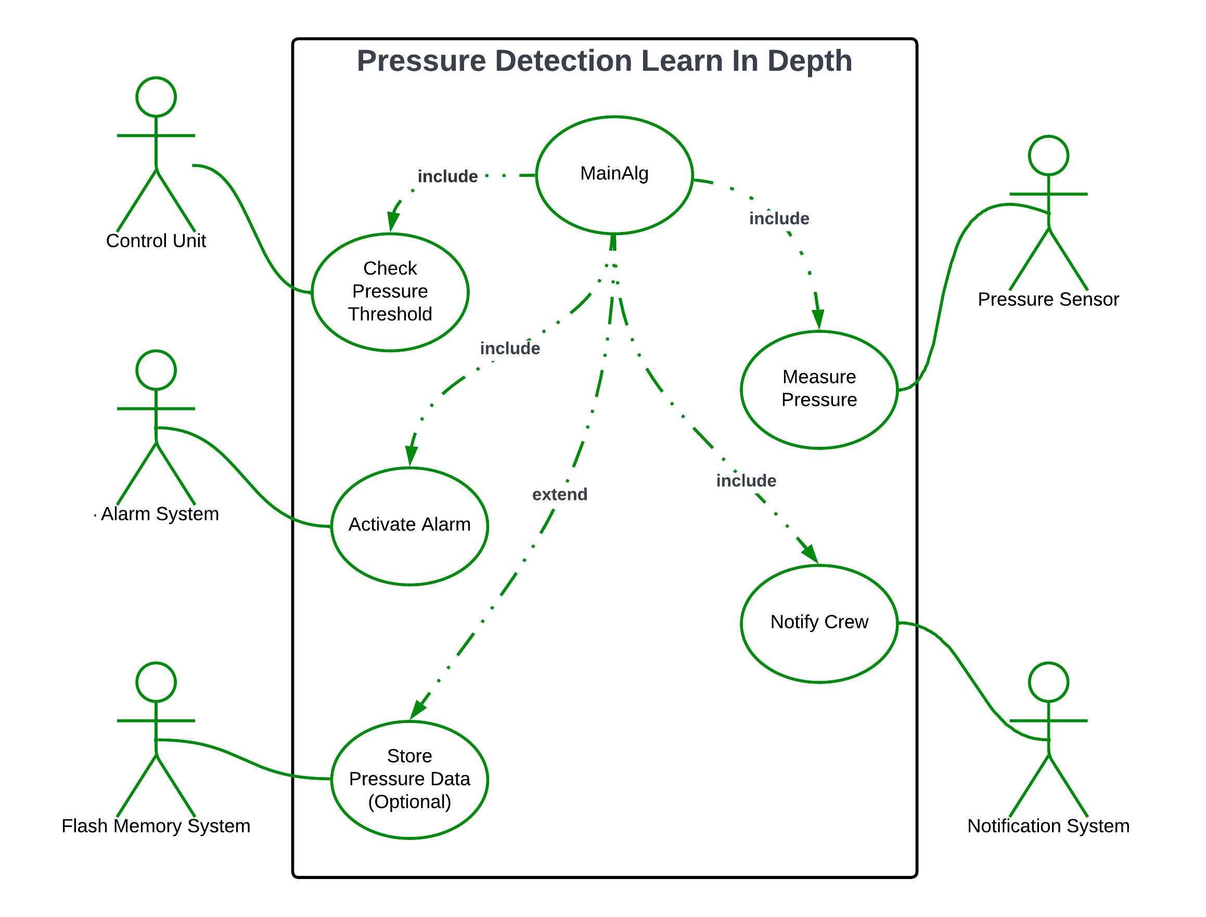

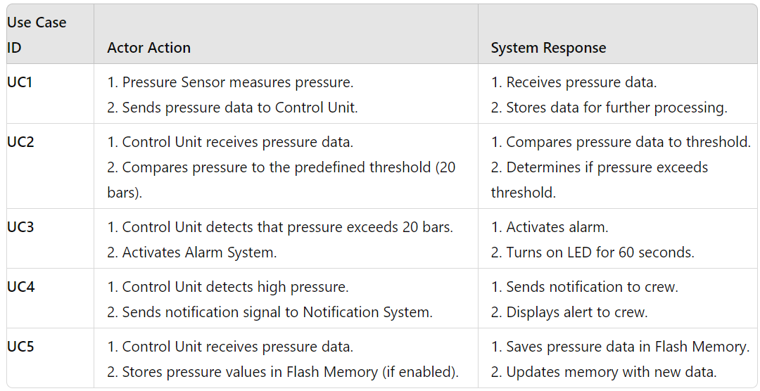
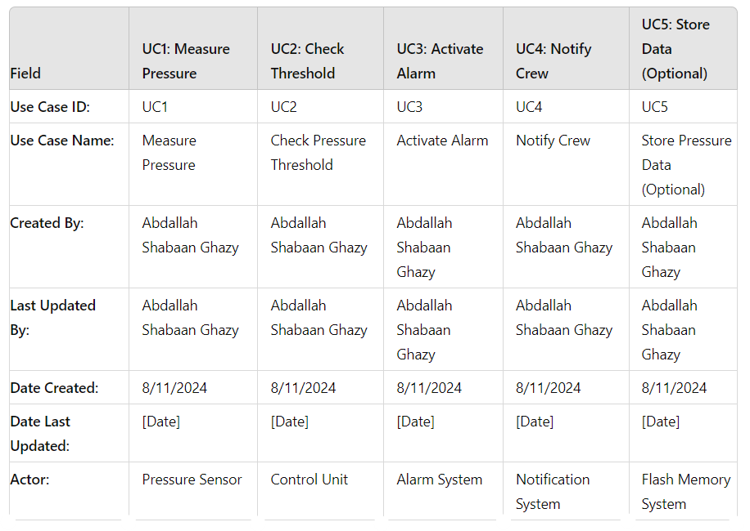

Use Case ID: UC1
- Use Case Name: Measure Pressure
- Created By: Abdallah Shabaan Ghazy
- Last Updated By: Abdallah Shabaan Ghazy
- Date Created: 8/11/2024

      - Actor: Pressure Sensor
- Description: The Pressure Sensor measures the pressure in the cabin and sends this data to the Control Unit.
- Preconditions:
- The Pressure Sensor is operational.
- The Pressure Sensor is properly connected to the Control Unit.
- Postconditions:
- The Control Unit receives the pressure data.
- Priority: High
- Frequency of Use: Continuous (as long as the system is active)
- Normal Course of Events:
- The Pressure Sensor measures the cabin pressure.
- The Pressure Sensor sends the pressure data to the Control Unit.
- The Control Unit receives and acknowledges the data.

- Alternative Courses:
UC1.AC1: If the Pressure Sensor fails to measure pressure, an error message is sent to the Control Unit.
- Exceptions:
UC1.EX1: If sensor data transmission fails, an error is logged, and the system attempts a retry.

Use Case ID: UC2
- Use Case Name: Check Pressure Threshold
- Created By: Abdallah Shabaan Ghazy
- Last Updated By: Abdallah Shabaan Ghazy
- Date Created: 8/11/2024

- Actor: Control Unit
- Description: The Control Unit compares the received pressure data against a predefined threshold of 20 bars.

- Preconditions:
- Pressure data has been received from the Pressure Sensor.
- Postconditions:
- The Control Unit determines if the pressure exceeds the threshold.
- Priority: High
- Frequency of Use: Continuous (as long as the system is active)

- Normal Course of Events:
- The Control Unit receives pressure data from the Pressure Sensor.
- The Control Unit compares the data to the predefined threshold of 20 bars.
- If the pressure exceeds 20 bars, the system proceeds to activate the alarm.

- Alternative Courses:
UC2.AC1: If the threshold value needs adjustment, the Control Unit re-calibrates the threshold
- Exceptions:
UC2.EX1: If there is an error in threshold comparison, the system logs the error and attempts to correct it.
- Includes: None
- Special Requirements: The threshold value must be configurable.
- Assumptions: The Control Unit has access to the correct threshold value.
- Notes and Issues: None

Use Case ID: UC3
- Use Case Name: Activate Alarm
- Created By: Abdallah Shabaan Ghazy
- Last Updated By: Abdallah Shabaan Ghazy
- Date Created: 8/11/2024

- Actor: Alarm System
- Description: If the pressure exceeds 20 bars, the Alarm System activates and the LED indicator turns on for 60 seconds.
- Preconditions:
- The pressure threshold has been exceeded.
- Postconditions:
- The alarm is active and the LED indicator is turned on.
- Priority: High
- Frequency of Use: As needed (when pressure exceeds 20 bars)
- Normal Course of Events:
- The Control Unit sends a signal to the Alarm System.
- The Alarm System activates the alarm and turns on the LED indicator.
- The LED remains on for 60 seconds.

- Alternative Courses:
- UC3.AC1: If the LED indicator fails, the alarm will still sound, and the issue is logged.
- Exceptions:
- UC3.EX1: If the alarm system fails to activate, an error is logged, and the system attempts to retry.

- Includes: None
- Special Requirements: The LED must be visible and clearly indicate the alarm state.
- Assumptions: The Alarm System and LED are in good working condition.
- Notes and Issues: None

Use Case ID: UC4
- Use Case Name: Notify Crew
- Created By: Abdallah Shabaan Ghazy
- Last Updated By: Abdallah Shabaan Ghazy
- Date Created: 8/11/2024

- Actor: Notification System
- Description: The system notifies the crew of high pressure conditions in the cabin.

- Preconditions:
- The alarm has been activated.
- Postconditions:
- The crew receives a notification.
- Priority: High
- Frequency of Use: As needed (when pressure exceeds 20 bars)

- Normal Course of Events:
- The Control Unit sends a notification signal to the Notification System.
- The Notification System delivers the notification to the crew.

- Alternative Courses:
UC4.AC1: If the primary notification system fails, a secondary notification method is used.

- Exceptions:
- UC4.EX1: If notification delivery fails, the system retries and logs the failure.
- Includes: None
- Special Requirements: Notifications must be clear and timely.
- Assumptions: The Notification System is operational and accessible to the crew.
- Notes and Issues: None

Use Case ID: UC5
- Use Case Name: Store Pressure Data (Optional)
- Created By: Abdallah Shabaan Ghazy
- Last Updated By: Abdallah Shabaan Ghazy
- Date Created: 8/11/2024
- Actor: Flash Memory System
- Description: The system stores pressure values in Flash Memory for historical record-keeping.

- Preconditions:
- Pressure data is available and needs to be stored.
- Postconditions:
- Pressure values are stored in Flash Memory.
- Priority: Medium
- Frequency of Use: As needed (for historical data recording)

- Normal Course of Events:
- The Control Unit sends pressure data to the Flash Memory System.
- The Flash Memory System stores the data in the designated section.

- Alternative Courses:
UC5.AC1: If Flash Memory is full, older data is overwritten or archived.
- Exceptions:
UC5.EX1: If data storage fails, an error is logged, and the system attempts a retry.

- Includes: None
- Special Requirements: Flash Memory must be sufficient in size and reliability.
- Assumptions: Flash Memory is operational and has adequate capacity.
- Notes and Issues: None

